Overview
- Why would we want to discern direction?

- Explore some current thinking about what we mean by ‘vision’ and leading a process of discerning direction.

- Some practical help in leading people in discerning God’s direction.

Key question – how do we guide God’s people through a process of discerning direction?

‘If any one idea about leadership has inspired organisations for thousands of years it’s the capacity to hold a shared picture of the future we seek to create. One is hard pressed to think of an organisation that has sustained greatness in the absence of goals and missions that become deeply shared throughout the organisation.’
Peter Senge

‘Visions are like lenses. They focus unrefracted rays of light. They enable everyone concerned with an enterprise to see more clearly what is ahead of them.’
Kouzes and Posner


Part 1: Defining Terms

What do we Mean by the Term Vision?
- Vision (noun) 1. The faculty or state of being able to see. 2. The ability to think about or plan the future with imagination or wisdom – a mental image of what the future will or could be like. 3. An experience of seeing something in a dream or trance, or as a supernatural apparition.’ Concise Oxford English Dictionary
- ‘An institutional vision is a clear and challenging picture of the future of the ministry as you believe it can and must be.’ Aubrey Malphurs
- ‘Vision for ministry is a clear mental image of a preferable future imparted by God to his chosen servants and is based upon accurate understanding of God, self and circumstances.’ George Barna
- ‘For organisations, a vision is an attractive, ideal future that everyone in the organisation can believe in, one that can realistically be achieved, yet offers a future that is better in important ways than what now exists.’ Richard Daft
- ‘Simply a picture of an ideal state of what the leader wants his or her organisation to be some time in the future.’ Matthew Richter
- ‘A clearly communicable picture of the future, steeped in value and philosophy, as well as structure.’ Stan Slap
- ‘Vision starts with frustration over what is and develops with determination to press towards what could be. Vision originates with the indignation of hindsight, the illumination of insight, and the imagination of foresight.’ David Pytches
- ‘Vision is like a magnifying glass which creates a focus, a bridge which takes us from the present to the future.’ Leighton Ford
- ‘Vision is seeing tomorrow so powerfully that it shapes today.’ Walter Wright
- ‘Vision is a powerful sense of what needs to be done and the initiative to take hold of it and work towards its completion.’ Ian Parkinson
- ‘Vision is the interpretation and application of mission into a specific context. In the church, vision sees, with an eye of faith, the ways that we can turn the Great Commission into a reality.’ Eddie Gibbs

A Framework

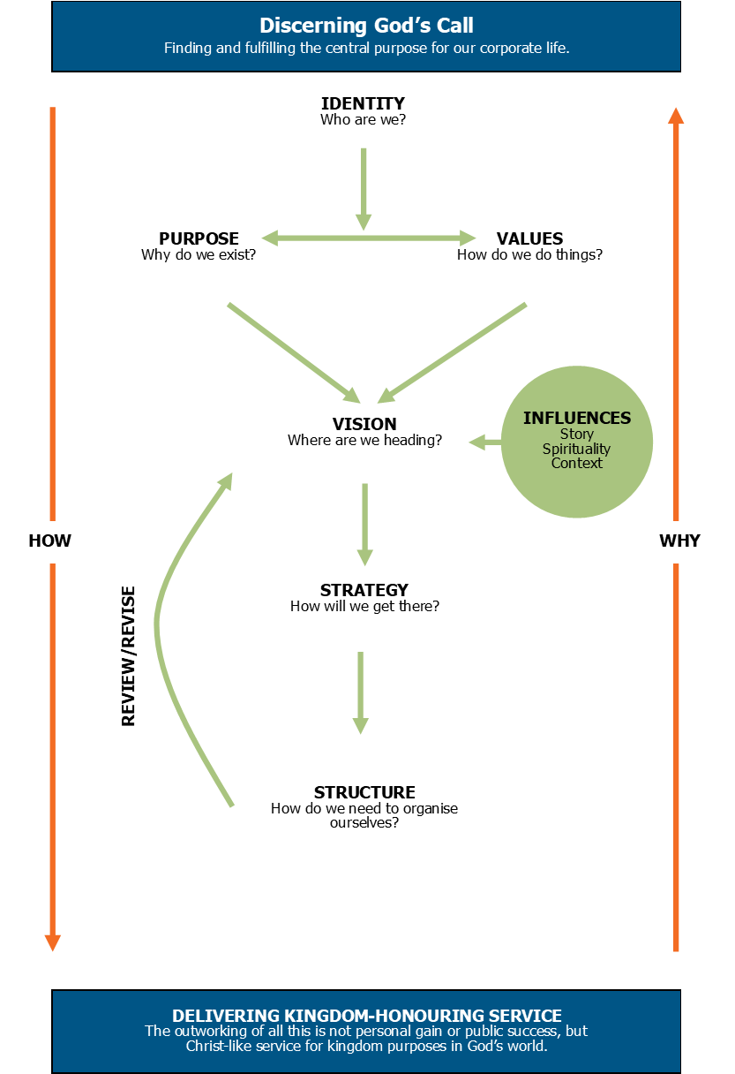

A Summary of Definitions

‘It is rare to find a congregation that has developed a mission statement out of Scripture study and then refocused all their activity to reflect that statement. It is even rarer to find Christian organisations that have done the hard biblical work of defining why they do what they do, organisations that have actually drafted what I call an operational theology of their mission… I can guarantee that when we work largely from unstated assumptions in our personal lives, churches or organisations, the values of the dominant culture are going to slip in and shape not only what we do, but how we do it. And we won’t even notice.’
Tom Sine

‘Vision is the interpretation and application of mission into a specific context. In the church, vision sees, with an eye of faith, the ways that we can turn the Great Commission into a reality. Whereas mission identifies what we are doing or should be attempting, vision is concerned with what we should become in order for that vision to be realised in our particular context.’
Eddie Gibbs

Identity
- Answers the question, who are we?
- Helps shape belonging and involvement.
- For a church its identity is given by Christ. We’re the body of Christ.

purpose
- Answers the question, why do we exist?
- It is an enduring statement that doesn't change. God decides the mission of a church (great commandment and great commission).
- Likely to be a short statement, and may be captured in a short pithy slogan or strap line.
- Mission needs to have a sense of ‘ooomph’ about it.

Values
- Answer the question, what guides how we do things? i.e. we're committed to doing things...
- Helps define distinctives. Values are what drive us on.
- Ideally relatively small in number, probably around four to six.
- Values need to have a sense of ‘aha’ about them.

Vision
- Answers the question, where are we heading? Where are we called to go?
- It is always future oriented. It needs to include destination, be clear, compelling and capturing. Vision often uses a refrain or a mental image, or a word picture to capture the imagination.
- It will be longer than the mission statement, and not a slogan.
- It will change as the circumstances of the organisation/church and character of individuals change, and as the vision is realised.
- It needs a time frame, probably 1-3 years, 3-5 years, or 5-10 years. However, after one year the vision will need to be reviewed and refined because of changing circumstances.
- Vision needs to have a sense of ‘WOW’.

Strategy
- Answers the question, how are we going to get there? Or how do we intend to realise the vision in a way that fulfils our mission and values? What areas of our activity will need to change?
- Targets (or aims): ideally four or five major things that need to happen to get us from where we are to where we want to be.
- Tasks (or goals/objectives): these are practical steps broken down into priorities, plans, action, responsibilities and timing. Ideally they need to be SMART (Simple, Measurable, Achievable, Reviewable, Timed).


Structure
- Answers the question, how do we organise ourselves to fulfil our mission.
- Structures need to serve strategies, not maintain the status quo.

Review/revise
- Answers the question, when do we know we’re there?
- Enables people and organisation to learn, develop, improve, grow.


‘There is no shortage of vision. The challenge of leadership is to gather all the vision from inside and outside the organisation, extract the best that matches the purpose, and then craft a vision statement that will unite the people in moving forward toward the common goal and a more desirable future.’
Leith Anderson

‘Vision leaks. It needs to be communicated clearly, creatively and continually’.
John Maxwell

1. Vision Gets Lost
Vision leaks – an illustration.

The parable of the lifeboat station.

2. Situations Change

The Congregational Life Cycle

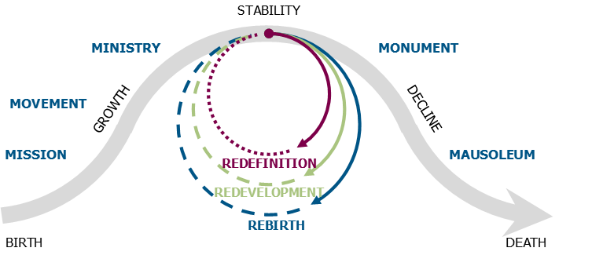

- Where are you on the curve?

- What has taken you to that place?

- What do you need to give attention to at this stage?


What Does Vision Do?

Generates Hope
- Vision gives meaning to those who are part of a congregation or organisation, releasing gifts to be used in fulfilment of the vision.
- Vision draws us closer to God because we draw closer to his will. It encourages dependence.

Sets Direction
- Vision identifies where God is leading this group of people, distinct from other groups of people.

Provides Clarity
- Vision helps decision-making; it is the final goal or standard by which all organisational decisions are evaluated.

Creates Ownership
- Vision captures imagination, inspires people, unites people around a known, agreed and owned direction.
- Vision generates resources.

Can you think of any instances where either the presence, or absence, of a clear and compelling vision has either helped, or hindered, the capacity of a church to fulfil its calling?

‘Does a planning process which involves evaluation and a long-range plan correlate with church growth? The answer is yes.’
Aubrey Malphurs

‘The congregation’s corporate vision becomes a path where there is no pathway; it brings clarity where there is obscurity and provides the impetus to keep going no matter how formidable the roadblocks… it lifts people to new realisations of possibilities, it generates enthusiasm and power, it aligns the thoughts, emotions and actions of people in pursuit of a common and compelling purpose.’
Shawchuck and Heuser

‘Leaders need to get others to see exciting future possibilities. They breathe life into visions. They communicate hopes and dreams so that others clearly understand and share them as their own. They show others how their values and interests will be served by the long term vision of the future.’
Kouzes and Posner

‘The great Christian revolutions came not by the discovery of something that was not known before. They happen when someone takes radically something that was always there.’
Richard Niebuhr

‘Someone has to take charge, to captain the ship. This doesn’t mean the captain attempts to do all the work or tells everyone what to do. S/he works closely with a team.
Aubrey Malphurs

‘Historians tend to write about great leaders as if they possessed a transcendent genius, as if they were capable of creating their vision out of some mysterious inner source… it usually turns out that the vision did not originate with the leader personally, but rather from others.’
Warren Bennis

- Listening to God.

- Listening to context.

- Listening to others.

Whom to involve?

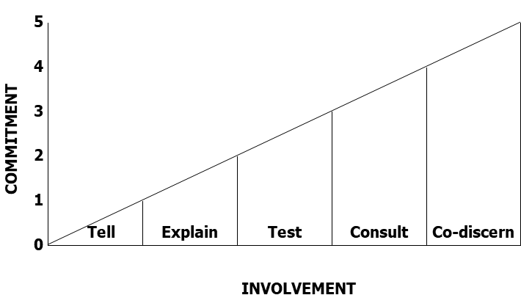

The Role of the Leader
- To initiate and steer the process.

- To define reality and foment dissatisfaction.

- To regulate the pace.

- To ensure clarity, communication and ownership.

- To challenge timidity.

- To maintain spiritual integrity.

‘Vision is a product of God working in us. He creates the vision and we receive it; it becomes a rallying point, a goal towards which we move as his people… Vision arises out of our burden to know the will of God… it calls us forth.’
Terry Fulham

‘Vision may begin with one person, but it is accomplished only through the efforts of many people.’
John Maxwell

‘Articulating the vision may be the single most important responsibility that a leader has.’
Walter Wright

Questions to ask before embarking on a process of discerning direction

- Is this the right step for us at this time?

- What approach are we going to use?

- Who are we going to involve?

- How far ahead are we looking?

- How long will we spend?

- What resources will we use?

- What are we aiming to produce as a result of this process?

A Variety of Models

Approach 1: Simple

Answer the question ‘where would God want us to be in three years time?’

- Ask people in casual conversation.

- Ask everyone to pray, think and listen attentively.

- Ask those in leadership with you.

Observations from Practice



Approach 2: Staged

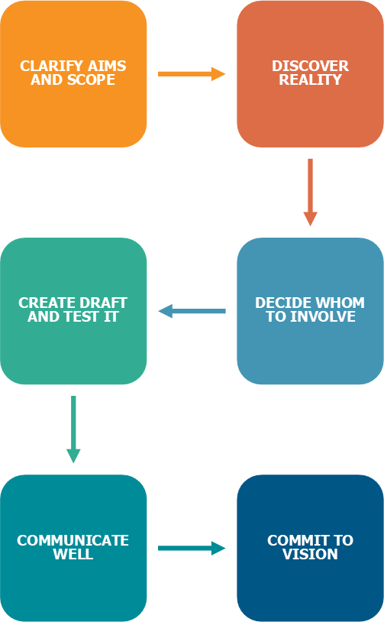

What Situation are You Leading Within?
Each situation is different, and each place differs at differing times. Which of the following scenarios best describes your situation at this time?

Start-up
You begin something new, seeking to gather what is necessary to launch something as a start-up. Start-ups include: launching a new congregation, planting a new church, starting a new youth work, opening a drop-in centre.

Turnaround
You take on a situation where things are in trouble, not as they might be. Work is needed to get things back on track. Turnarounds include: taking on leadership of a church in significant decline, or which is about to be closed; taking on a failing children’s work where morale is low among leaders, there are very few children left, and there is no vision for the work.

Realignment
Something needs to be revitalised because it has lost its original vision, passion and is drifting into trouble. It is still viable, but won’t be for long. You need to reinvent things. Realignments include: a medium size church where there has been no growth for a number of years and things are still comfortable, or a church where the previous minster has left after breaking the trust of the congregation; a home group structure where the groups haven’t grown and people love the group they belong to, but little real growth is occurring; a music group where the group enjoys playing together but is wanting to take the worship in a direction which doesn’t connect with the overall direction of the church.

Sustaining success
In this situation things are healthy and thriving (although not perfect, because they never are!). The challenge is to create a challenge, to spot the next curve that needs to be embraced. Sustaining success includes: situations where vision is clear, people are committed, growth occurs and the energy is palpable.

My situation is best described as...

The STARS Model
Taken from The First 90 Days, Michael Watkins, HBS Press

Recovery
Cycle
Fail
Succeed
Fail
Growth Cycle

Realignment

Sustaining Success

Turnaround

Start-up

Shutdown
Succeed
Succeed
Succeed
Crisis
Cycle
Fail
Fail

Transition  type | Challenges |  | Opportunities
Start-up | - Building structures and systems from scratch without a clear framework or boundaries.  - Welding together a cohesive high-performing team.  - Making do with limited resources. |  | - You can do things right from the beginning.  - People are energised by the possibilities.  - There is no pre-existing rigidity in people's thinking.
Turnaround | - Re-energising demoralised employees, other stakeholders.  - Handling time pressure and having a quick and decisive impact.  - Going deep enough with painful cuts and difficult personnel choices. |  | - Everyone recognises that change is necessary.  - Affected constituencies (such as diocese who want the church to stay open) may offer significant external support.  - A little success goes a long way.
Realignment | - Dealing with deeply ingrained cultural norms that no longer contribute to high performance.  - Convincing people that change is necessary.  - Restructuring the top team and refocusing the organisation. |  | - The organisation has significant pockets of strength.  - People want to continue to see themselves as successful.
Sustaining success | - Playing good defence by avoiding decisions that cause problems.  - Living in the shadow of a revered leader and dealing with the team he or she created.  - Finding ways to take the business to the next level. |  | - A strong team may already be in place.  - People are motivated to succeed.  - Foundations for continued success (such as the process for growing leaders or excellent events) may be in place.

Approach 2: Staged

Step 1: Clarify Aims and Scope
- Why this process at this time?

Step 2: Discover Reality
- The importance of problem casting.
- The importance of refusing to minimise difficulties.
- Using a variety of tools including e.g. SWOT analysis.
- Understanding the power of creative tension.

Step 3: Decide whom to involve
- Depends on size of church.
- Always involve those whose positional role gives them particular responsibility for area under consideration.
- Don’t avoid the challenging voices.

Step 4: Create draft and Test it
- Key stakeholders.
- Those directly affected by the proposed vision document.

Step 5: Communicate it well
- Stimulating imagination as well as intellect.
- Reinforcing it by how we deploy ourselves.

Step 6: Commit to it
- Leaders are called to commit to the vision, to embody it in their daily life, be prepared to pay a price, to make hard decisions. There is only one thing worse than no vision, and that is a long and costly process of discerning a vision which produces passion in people… and then nothing is done about it!

‘The essence of leadership is the ability to influence others to volunteer their separate energies and resources to a common pursuit. This rests on the leader’s ability to communicate the vision in a clear, convincing and compelling manner. The communication must excite not only people’s intellects but also their imagination and passion.’
Shawchuck and Heuser

‘Both formal and informal leaders communicate their vision by how they spend their time, what they talk about, what problems they solve first, and what they get excited about. In every act, leaders reinforce the values they hold and the vision they hope to achieve.’
Bennis and Nanus

Approach 3: Story
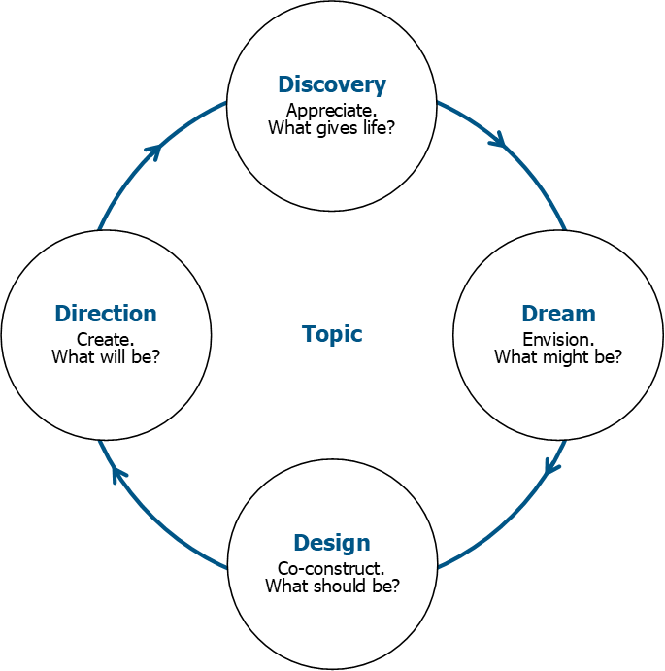

Appreciative Inquiry (AI) is a particular way of asking questions and envisioning the future that fosters positive relationships and builds on the basic goodness in a person, a situation, or an organisation. In so doing, it enhances a system’s capacity for collaboration and change. Appreciative Inquiry utilises a cycle of four processes focusing on:

- Discovery Appreciate the best of what is.
- Dream Imagine what could be.
- Design Determine what should be.
- Direction Create what will be.

The basic idea is to build organisations around what works, rather than trying to fix what doesn’t. It is the opposite of problem solving. Instead of focusing on gaps and inadequacies to remediate skills or practices, AI focuses on how to create more of the exceptional performance that is occurring when a core of strengths is aligned. It opens the door to a universe of possibilities, since the work doesn’t stop when a particular problem is solved but rather focuses on ‘What is the best we can be?’ The approach acknowledges the contribution of individuals, in order to increase trust. The method aims to create meaning by drawing from stories of concrete successes and lends itself to situations where confidence is low, people have been ‘burned’ by other approaches, and collaboration is key to forward movement.
(Taken from Wikipedia, adapted.)

AI assumptions:
- In every organisation some things work well.
- What we focus on becomes our reality.
- Asking questions influences the group.
- People have more confidence in the journey to the future when they carry forward parts of the past.
- If we carry parts of the past into the future, they should be what is best about the past.
- It is important to value differences.
- The language we use creates our reality.
- Organisations are heliotropic (they lean towards a source of energy – healthy or unhealthy).
- Outcomes should be useful.
- All steps are collaborative.
Mark Branson, Memories, Hopes and Conversations, The Alban Institute

See also Congregations as Learning Communities, Dennis Campbell, Alban Institute

Key resources
www.alban.org/conversation.aspx?id=3674
for an expanded version of the ten assumptions listed above.

www.vancouver.anglican.ca/Portals/0/Repository/AppreciativeWayredesigned.c77309b2-b03f-440e-bf4b-d01e29268ef1.pdf
for a guide to conducting an appreciative inquiry session.

www.clergyleadership.com
for a website dedicated to appreciative inquiry in churches.

Observations from Others’ Experience

Appreciative inquiry.

Provocative proposals.

Mission map.

Six Critical Questions
1. Why do we exist?
2. How do we behave?
3. What do we do?
4. How will we succeed?
5. What is most important right now?
6. Who must do what?
The Advantage, Patrick Lencioni

How do we Guide God’s People through a Process of Discerning Direction?
Given all that we have thought about today, what do I need to do next in my situation?

‘Questions that generate passion and excitement.
Clarity about process; fluidity about the outcome.
Lead and grow from your strengths.’
Marcus Buckingham

Listen

Organic

Bottom Up

Keep it biblical

‘Leadership has its foundation in our understanding and interpretation of God and God’s purposes for the world. The most creative church leadership is that which is deeply rooted within the life of God.’
Elisabeth Welch

Action Learning Sets in Peer Cells

What is Action Learning?
A fancy name for a useful concept! Action learning is in essence about using the support of a group to solve problems and get things done. The notion of a ‘problem’ in this context is anything which is unresolved or partially formulated with which one’s mind is pre-occupied.

Action learning is both about both learning from action and taking action from learning. It is a reflective process involving a small group (normally no more than six people) focused on one member’s issue.

It takes time to ‘learn’ how to do action learning well. Don’t give up after one attempt, especially if it didn’t go too well! Any cell has to learn how to relate to one another and grow the trust that makes action learning a possibility.

How Does it Work?
Within a peer cell meeting (normally two to three hours) you will need to decide if you are going to use action learning ahead of the meeting. Each person will need to come having identified a problem/issue they are prepared to talk about within the cell. It is essential that each person identifies a real issue, thus making themselves vulnerable to the cell. Each person is allocated 30-45 minutes with suitable space for a break between each part. The ‘airtime’ will involve the following components, although a great deal of flexibility is needed within the framework.
- Presentation An individual presents an issue. It needs to be real, alive and something which pre-occupies the mind of the individual.
- Reflection Other members of the cell help the individual find a way forward for their issue, primarily through asking ‘open’ questions (i.e. not answerable with a yes or no). The main types of questions are:
clarifying – to help the individual clarify the situation.
challenging – to help the individual achieve insight.
catalytic – to trigger new ideas.
The ideal question is brief, incisive and elegant. The questions should lead the individual to define the issue more precisely, identify potential solutions, create options, and select a way forward.
- Decision The individual decides a way forward, shares it with the cell who then pray and support them in their action, and hold them accountable by asking how it went when they next meet (or before then if appropriate).

This cycle then repeats itself for each member of the cell.

What Makes for a Good Action Learning Experience?
No two cells will work in quite the same way, but here are some guidelines that are likely to make for a good experience.

- Build rapport A good action learning experience flows from relationships of trust and authenticity. This takes time, but the whole design of Arrow will hopefully help with this. It is likely that you will start with smaller and less personal issues and as trust builds will move to more personal and more complex issues. The aim is to create a supportive environment where real issues can be shared and explored without fear of judgment.

- Respect confidentiality The only thing that leaves the action learning experience is the learning. It is vital cell members know that things won’t be shared outside the cell.

- Appoint facilitator It will help to appoint a facilitator from within the cell. Their role is to:
- Ensure physical comfort of the cell.
- Keep an eye on timing, and ensure you finish within the allocated time.
- Invite presenter to bring their issue.
- Indicate start of questions when the presenter has finished the above.
- Ask clarifying questions when needed (How can we help you? Where would you like to be by the end of this time?).
- Pick up on what is happening, slow things down if people are asking too many questions, too quickly.
- Ensure cleanness of the process – no advice/anecdotes.
- Moving the process on (presenting issue, reflecting on issue through questions, identifying options, and selecting a way forward).
- Note action points, checking ownership of the issue remains with the presenter.
- Ensure the process ends well.

This role can change each time you move on to a new person.

- Take ownership The focus is on your issue/problem, and the resolution will involve you taking responsibility for your assumptions, attitudes and actions. As someone has summarised ‘I am part of the problem and the problem is part of me.’ Only the owner of the problem can decide upon the right course of action for them.

- Don’t tell The tendency is to tell the person what to do rather than support and ask questions. Listening and questioning by the cell is focused on better understanding and insights and on supporting the problem-owner rather than on solving the problem for them. The presenter of the issue should do most of the talking. There is no place for others to share their own issues or stories during someone else’s time. It may be appropriate to engage in creative brainstorming/inputting ideas, but it helps if it is clearly identified when this begins and ends.

- Be creative A good action learning experience will involve creativity, playfulness, experimentation and laughter. Although serious and painful problems may be aired, it doesn’t mean the atmosphere needs to be intense or heavy the whole time.

- Review well It is helpful to review how the process went, each person learning through the experience. Questions to help with such a review include:
- How did I contribute?
- What could I have done differently?
- What other questions could have helped?
- What have I learned from exploring another person’s issues?
- What action do I want to take? When?

In Summary
The acronym RECIPE is a helpful way of summarising the action learning approach.

R esponsibility for oneself – I must take responsibility for my issue.
E xperience-led – the issues presented are real issues, something I am struggling with, not theoretical.
C onfidentiality – the only thing taken out of the cell is the learning.
I anguage – avoid ‘you’ language.
P rocess – pay attention to the process as much as the content. How are people feeling?
E quality – everyone has the same opportunity to contribute.

….and Finally
What would stop us from ‘guiding God’s people through a process of discerning direction?’ Normally either:

The People…
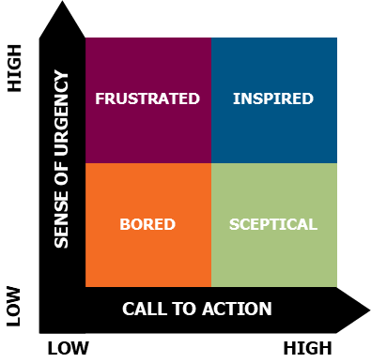
- Don’t see the need.

- Worried about losing good things or making the same mistakes as before.

- Don’t know how to play their part.

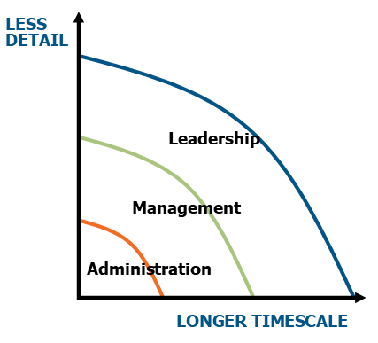
Or the Leader…

- Inspiration.

- Use of time.

‘Most visions come from a lengthy process of learning, praying, observing, brainstorming with others, trial and error, rough drafts, false starts, refinement, partial agreement, eventual adoption and incremental implementation.’
Leith Anderson

‘Carefully planned strategies will only get us so far in understanding God’s way forward. This is not to diminish their importance in any way. Christian leaders have a God given responsibility to use their power of reason, imagination and intellect. But the experience of God’s people again and again has been that it is God’s surprises rather than their own plans that open up the future in remarkable ways… God is a God of life and growth, and growth is irregular and unpredictable, but also irrepressible and thrillingly beautiful. If things point in one direction, but God seems to be leading somewhere else, our advice is go for God every time.’
Mark Ireland and Mike Booker (adapted)

‘In essence, creative leadership is about doing things differently to make the most of the opportunities in the environment. As such it requires courage – to release other people’s creativity, to face their anxieties about change, to learn what is working and what is not, and to live with the loneliness of moving people and an organisation at a pace that will by definition be too fast for some, too slow for some, and the wrong direction for others.’
Gillian Stamp


Clearing Blockages

- What do I need to clarify to enable me to proceed?

- What action am I going to take as a result of today?

- What are the greatest challenges I am going to face which might threaten my capacity to undertake such actions?

- What might I do to mitigate such threats?

