Resilience has become a bit of a buzz phrase in recent years, alongside wellbeing and flourishing. The impact of the extraordinary events of the last two or three years have highlighted the need for personal resilience, not just in leadership, but in so many aspects of our lives. What do we mean by ‘resilience’? What does it mean to be a resilient leader? What does a resilient life look and feel like? How does one develop resilience?

There are a variety of ways in which ‘resilience’ is understood and used. If you type ‘resilience’ into Google you get 124 million options! It can be used to mean – ‘the capacity to bounce back’ or ‘doing better that you’d think under the circumstances’. There is currently discussion about whether resilience is something inside you, that you are born with or something that you can develop. Resilience is often given as the reason for one person coping apparently better with adversity than another person. A discussion is developing about whether resilience is just personal or also institutional; many organisations like health providers, relief and development agencies and schools, are trying to work out what it means to be resilient.

Today we are exploring personal resilience, here are a handful of definitions to get us thinking:
- The capacity to recover quickly from difficulties; toughness. (Oxford English Dictionary)
- The quality of being able to return quickly to a previous good condition after problems. (Cambridge English Dictionary)
- The ability to recover readily from illness, depression, adversity, or the like; buoyancy. (Google)
- Overcoming adversity, whilst also potentially changing, or even dramatically transforming, (aspects of) that adversity. (Boing Boing, a charity working with disadvantaged children)

underground

identity
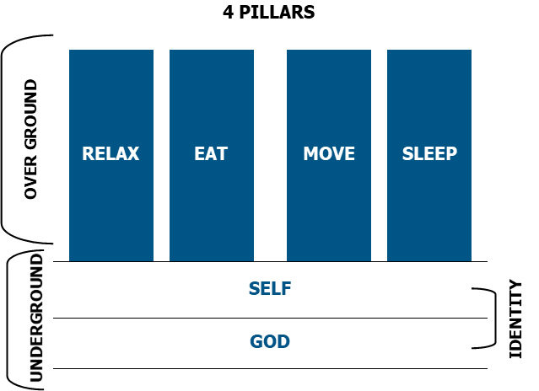

Building resilience often concentrates on what we do and how we do it – exercise, time off, nutrition, etc, which are like pillars in our life. Over the past year you may have strengthened some or all of these pillars, personally. If not, I can suggest an excellent book called ‘The 4 Pillar Plan’, by Dr Ranjan Chatterjee that can resource you if these are areas of resilience building that you would like to explore further. In the session today we will focus on the foundations of self and God, which is the place in which identity is understood and shaped. When the foundations of God and our self, are strong we have more inclination and more energy to invest in strengthening the pillars and thus our resilience.

WHO OR WHAT DEFINES ME?

Reflecting on Jesus’ Experience of Temptation in the Wilderness

Matthew 3:13-4:11
Then Jesus came from Galilee to the Jordan to be baptized by John. ¹⁴ But John tried to deter him, saying, “I need to be baptized by you, and do you come to me?”

Jesus replied, “Let it be so now; it is proper for us to do this to fulfill all righteousness.” Then John consented.

As soon as Jesus was baptized, he went up out of the water. At that moment heaven was opened, and he saw the Spirit of God descending like a dove and alighting on him. ¹⁷ And a voice from heaven said, “This is my Son, whom I love; with him I am well pleased.”

Then Jesus was led by the Spirit into the wilderness to be tempted by the devil. ² After fasting forty days and forty nights, he was hungry. ³ The tempter came to him and said, “If you are the Son of God, tell these stones to become bread.”

Jesus answered, “It is written: ‘Man shall not live on bread alone, but on every word that comes from the mouth of God.’”

Then the devil took him to the holy city and had him stand on the highest point of the temple. ⁶ “If you are the Son of God,” he said, “throw yourself down. For it is written:

“‘He will command his angels concerning you,
and they will lift you up in their hands,
so that you will not strike your foot against a stone.’”
Jesus answered him, “It is also written: ‘Do not put the Lord your God to the test.’”

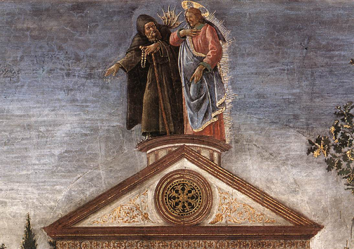
Again, the devil took him to a very high mountain and showed him all the kingdoms of the world and their splendour. “All this I will give you,” he said, “if you will bow down and worship me.”
Three temptations of Christ, Botticelli, Sistine Chapel

Jesus said to him, “Away from me, Satan! For it is written: ‘Worship the Lord your God, and serve him only.’”

Then the devil left him, and angels came and attended him.

This question ‘Who or what defines me?’ is one that we will return to during the day. The hope is that it might become a useful tool for you as you consider your resilience and as you develop your resilience in leadership.

Pressure/Performance Curve
Adapted from Managing Workplace Stress, Stephen Williams and Lesley Cooper

Level of Pressure

Performance

Chill Out

Burn Out

Strain

Stretch

Work Out

Chill out
At low levels of pressure, there is often low performance i.e. on those days when nothing much needs doing, nothing much gets done! There is nothing wrong with this, we all need chill out days in which to recharge our batteries, change down a few gears and watch the sun set.

Work out
In the ‘work out’ zone every increase in pressure brings a corresponding upturn in performance. As the pressure increases we think more rapidly, move faster and make decisions more quickly. The key aspect of this zone is that it is sustainable – we can do it again tomorrow and the next day and the next. We are well within our ability to cope and can often get a great deal of satisfaction from how much we feel we are achieving as we move up the curve.

Stretch
In the stretch zone the performance curve is still going up. Now the adrenalin is flowing, we are pulling out all the stops, and we are delivering! Yet we are also aware that we are emptying the cupboard – depleting our reserves. Underneath all the activity is the awareness that we cannot carry on at this pace – we need an end point, a deadline, a stop date – after which time we know we will be able to relax. If our ‘end point’ gets postponed or cancelled, or the pressures continue to mount, then we may find ourselves in strain.

Strain
In the ‘strain’ zone we have gone past the maximum effective pressure point and are heading down the slippery slope. Now things are starting to go wrong – mistakes at work, failure to communicate, increased likelihood of illness and we are feeling unable to cope, with life getting out of control. Should the pressures continue, then we are at risk of damaging ourselves physically, emotionally, and in our relationships.

Burnout
People experiencing burnout often feel angry, helpless, trapped, and totally depleted. Usually people have been under considerable pressure for a prolonged period and this may have been aggravated by personal conflicts and unattainable goals. ‘The major defining characteristic of burnout is that people can’t or won’t do again what they have been doing.’ Cynicism and negativity often accompany the burnout experience.

Christina Maslach, a researcher at University of California at Berkeley, says that burnout ‘refers to a syndrome of emotional exhaustion and cynicism that frequently occurs among people who do “people work” – who spend considerable time in close encounters.’

Activity

- What feelings might be associated with each section of the curve?

- Where are you spending most of your time at the moment? How do you know? What impact is this having on you and others?

- If where you are feels like a good and healthy place, what is your learning or observing about maintaining this?

- If where you are is taking life and depleting your resources, what are you learning or observing about yourself and how you got to this place?

Cycle of Grief

3. Drivenness
We’re driven to achieve more to make ourselves acceptable to others and ourselves.

2. Identity
Our sense of significance is dependent on what we achieve, so we push on.

4. Acceptance
The sense of acceptance is temporary and fragile, so we go round the cycle once again.

1. Achievement (activity)
We achieve to provide
ourselves with an identity.

The cycle of grief erodes our confidence in our identity as children of God. Rather than rest securely in Christ we seek assurance and acceptance from others. What we do and how we are seen by others is central to how we see ourselves. Our sense of self and significance is determined by what we achieve, which pushes us into driven-ness, our acts of service become more about our identity than about an outpouring of the love and grace we have received from God. Acceptance by others in response to what we do and how they see us is short-lived, temporary and fragile, which compels us back around the cycle seeking yet further affirmation and acceptance from others, defining ourselves in response to how others regard us.

The Cycle of Grief is like an infinite mountain of accomplishments, with false summits, solo climbing, falling back down and never getting there.

Cycles of Grief

- What strikes you about this cycle?

- What aspects of your own life and ministry are caught in this cycle, how does that impact on you and on others?

- What might some of the underlying reasons be for being caught in this cycle?

- How might this cycle impact on your identity?

- How might you move into the cycle of grace in these areas? Perhaps identify one area of your life or ministry, which could move from grief to grace.

Cycle of Grace

2. Sustenance
Resources constantly renewed through dependence on God.
(Ephesians 2:7)

3. Identity
Sense of significance.
(Ephesians 2:6)

1. Acceptance
Unconditional grace.
(Ephesians 2:4-5)

4. Fruitfulness

(achievement, service)
In loving, obedient ministry.
(Ephesians 2:10)

In contrast the Cycle of Grace starts from a place of knowing we are accepted, loved and forgiven by God, that our identity is in Christ. We have received the unconditional grace of God. As this grace overflows from us we are constantly renewed through our dependence on God. Our sense of significance is as a child of God, our identity is in Christ. The fruitfulness of our words and actions are a result of our loving obedience and are our offering back to God. This propels us back to God’s life-giving, unconditional grace and love.

The Cycle of Grace is like a joyful dance, a barn dance, a community dance, with different dances and different paces, we can shout out if breathless, there is good natured laughter if we fall over, the dance becomes a story.

Cycles of Grace

- What strikes you about this cycle?

- What aspects of your life and ministry are found in this life-giving cycle, how does that impact on you and on others?

- How might this cycle impact on your identity?

- How is your leadership shaped by the cycle of grace?

- How can you develop and grow into this cycle more and more in your life and ministry?

Who is in the driving seat of your life and ministry? As humans we are a complex mix of all that has happened to us, all that we have learned, all that we have developed and nurtured in ourselves and all that God has transformed and is transforming, in us. How we see ourselves, our identity and what we expect of ourselves are shaped by this complexity. There will be times in our life and indeed, moments during each day when God is in the driving seat. However, there will also have been times in our life and times in each day, when coming from our broken self we push God out of the way and take over. What are the drivers that tend to sit in the driving seat of your life, instead of God?

Perfectionist – Be perfect
In the household in which the Perfectionist grew up the values were success, achievement, autonomy or ‘being in control’ and competition. Their fears:
- Loss of control.
- Not being told what’s going on.
- Failure to achieve goals.
- Things not being done right.

Under pressure Perfectionists can become arrogant, sarcastic and any ability to multi-task disappears as they become more single-minded and rigid.

People pleaser – Please others
The values of the People Pleaser are co-operation, consideration, and the service of others. Their fears:
- Rejection or criticism.
- Not being liked or included.
- Being thought ‘awkward’.
- Conflict.
- Upsetting people.

Under pressure People Pleasers are likely to become more emotional and go into ‘rescuing’ behaviour.

Activist – Hurry up
The values of the Activist are energy, speed, activity and efficiency. They relax by going for a run or working out at the gym. Their fears:
- Having nothing to do.
- Wasting time.
- Time to think.
- Boredom.

Under pressure Activists become more frenetic, with much visible activity but little achieved.

Saviour – Be strong
The values of a ‘Saviour’ are strength, courage, reliability and independence. A saviour is often self-sufficient; solitary; reliable; helpful whilst unable to accept help. Their fears:
- Their own vulnerability or weakness.
- Not coping.
- Letting people down.
- Asking for help.

Under pressure Saviours withdraw and stop communicating, they don’t want people to know about the mess inside and prefer to sort it out in solitude, reappearing once they have got themselves together.

Striver – Try harder
The values of a ‘Striver’ are determination, endurance, and effort. They love any new or different task but their initial interest wears off before they finish. Their fears:
- Not having put in enough effort.
- Being thought irresponsible.
- Giving up.
- Finishing.

Under pressure Strivers put more and more effort into trying without much achievement, they take on more and more, believing they are only accepted if they are trying hard, they tend to become reactive.

When God is in the driving seat our identity is in Christ and our security in God’s unconditional grace. We serve and minister from that place of power and love and self-control (2 Timothy 1:7) and our identity is shaped by the way God sees us.

When our drivers are in the driving seat, our identity is shaped by our expectations of ourselves and of others, our sense of significance determined by our driven-ness to be perfect, to please others, to get things done, to be self-sufficient or to put in even more effort. This takes us into the Cycle of Grief in which we are in an endless cycle of approval and acceptance that does not bring us peace or a true sense of ourselves in Christ. Our drivers drain us, take from us and do not replenish us. Our drivers are often fed as much by the expectations of others as by our expectations of ourselves – defining us as perfectionist, people pleaser, activist, saviour or striver from which it is difficult to break free in the face of their disappointment in us or judgement of us.

Activity:

- What are your primary driver/s?

- What are the positive gifts that come from this/these driver/s?

- What is the impact of these drivers on you and on those around you?

- In what ways do your driver/s impact on your identity and sense of yourself?

- What practical steps can you take to begin to self-limit the drivers in the future?

Word or Phrase

- Think back to when you were growing up, might there have been a phrase used that has perhaps become part of your way of seeing yourself and the world: ‘goodey two shoes’, ‘fidget-bottom’, ‘I’m relying on you’, ‘don’t let me down’, ‘what will people think’.

- Does the phrase/phrases that you recall relate to the drivers that have emerged in your questionnaire? How might you begin to break the hold the phrase still has on you, however subtly or subconsciously? What new phrase, rooted in your identity in Christ and God’s unconditional grace, might you begin to utter instead?

Beginning New Patterns
- Ask God to show you where your identity is being defined by your drivers.
- Enable your peer cell, mentor or accountability group to support and accompany you as you limit and attend to the drivers personally.
- Identify a spiritual discipline that may help you refocus on your identity in Christ when your drivers take over the driving seat of your life and ministry.
- Begin to positively address some of the fears of the drivers – delegate, ask for help, stop, say ‘no’, take time to relax.

Anxiety is a term that is being used a lot at the moment. It has many different applications and meanings. This is how we are using anxiety in this session.

Anxiety An automatic emotional response to a threat, real or imagined, experienced as an unfocused sense of discomfort.
Leading in Anxious Times, Bridge Builders

We share this automatic reactivity with the animals, imagine a herd of gazelles when one of them gets the scent of a lion. It can be helpful to imagine anxiety like an electric current; we may be able to recall occasions when we have watched the ‘electric current of anxiety’ ripple through a congregation, our family or colleagues in the office.


Family Systems Theory (FST) is a theory with roots in Murray Bowen’s work in family therapy. This was developed by Edwin Friedman to apply to the leadership of congregations. A basic premise of FST is that each of us develops habits to deal with anxiety – our emotional reactivity the feelings of unfocused discomfort. We develop most of our anxiety habits in our family or context of origin and the anxiety habits we experienced there.

The aim of our anxiety habits is to reduce the sense of discomfort we feel, here are some examples:
- Passing anxiety to others (‘have you heard…‘).
- Removing ourselves emotionally or physically (we stop contributing to discussions at meetings, or we may stop attending).
- Attacking the person we perceive to be the cause of our discomfort (‘I don’t enjoy the vicar’s sermons, they aren’t as good as their predecessor’).
- Absorbing the anxiety, finding it less and less bearable (burdened with worry about everyone and everything).
- Identifying so strongly with the anxiety of another person that it becomes our own (we start seeing the world in the same way as them).

Our anxiety habits are how we deal with the increased anxiety we experience, in the face of a perceived threat, real or imagined, to re-establish our ‘normal’ levels of emotional comfort. Some of us live with high levels of anxiety as ‘normal’, which means that even a small spike of additional anxiety results in a disproportionate reaction. The higher the level of anxiety (emotional discomfort and reactivity) we experience the harder it is to think objectively, clearly and calmly, the harder it is to keep an open and balanced view of other people, the harder it is to empathise with others, particularly those whom we perceive to be a threat and the cause of our increased anxiety.

To what extent does your way of handling anxiety mean that your experience of anxiety defines who you are?

Emotional triangles are one of the main ways in which anxiety (emotional reactivity and discomfort) is managed and passed to others. A third person is brought into the dynamic, either as the focus of anxiety or as a person with whom to form an alliance and on whom to dump anxiety. We are all in a myriad of emotional triangles, which are fluid and every changing. When the purpose of a triangle is for me to off-load my anxiety so that I can restore my ‘normal’ level of emotional comfort, the triangle becomes a way in which anxiety is transmitted to others.

A
C
B
A and B share an experience B’s anxiety rises.
B talks to C about A.

The events of recent years have meant that for many people levels of anxiety, of emotional discomfort and reactivity, have increased. Triangles are a way of dealing with this, e.g. moaning about the Government or some other 'them', criticising those who are more or less cautious about covid. As leaders we will find ourselves ‘triangled, becoming the third corner of triangles. Triangles are an attempt to draw the leader in so that others can reduce their emotional discomfort and anxiety, by passing it to the leader. Very often the attempt to triangle is to form an alliance, when the person being triangled agrees (or perhaps doesn’t disagree), this forms, at least a perceived alliance, which lowers the emotional discomfort. Along with anxiety it is often the case that people hope to leave ‘responsibility’ in the triangle too, especially when the leader is being brought into the triangle as the third person. By telling us something of concern, the (often unspoken) assumption is that the leader will sort it out.

anxiety responsibility

Unless we are aware of the emotional triangles in which we find ourselves as leaders, we are likely to find the anxiety, sense of responsibility and emotional discomfort of others defines what we do, how we react and how we see ourselves – our identity. We will get sucked into triangles and find ourselves exerting loads of energy trying to manage other people’s anxiety and emotional discomfort.

Detriangling
The purpose of emotional triangles is to pass anxiety and responsibility to a third person in order to reduce the reactive sense of emotional, unfocused discomfort. When leaders develop detriangling skills we learn to resist the temptation to absorb the anxiety and take on the responsibility, instead we pass the anxiety and responsibly back into the triangle and invite others in the triangle to take responsibility for dealing with the anxiety themselves.

C detriangles by inviting maturity from B, passing the anxiety back and exploring appropriate responsibility.
A
C
B

The anxiety and responsibility being passed to us is a temptation to be defined by the anxiety of others and their expectations of us. If we are not clear about our identity and role, the temptation in the triangle may seduce us (often also in partnership with our drivers) and start to define what we do, how we see ourselves and how others see us.

Detriangling is a skill we can develop as we mature and take more responsibility for ourselves and less responsibility for others. Detriangling is an invitation to others to ‘grow up’ into maturity. Detriangling gives an opportunity for discipleship, as we invite those in the triangle to learn to live with their increased emotional discomfort and to take responsibility for it. For example, we might encourage them to talk directly to the other person in the triangle, or to give their anxiety to God trusting God for it; we might ask them to think about the extent to which their perception and judgements are right; we might invite them to let go of what they are bothered about.

Detriangling requires us to be growing in maturity so that we can stay emotionally connected without taking on the anxiety and responsibility that belong elsewhere. Detriangling isn’t being distant and removed, it is being appropriately connected and boundaries.

Activity
- Break into twos.
- Person A is going to come with a complaint, concern or moan about someone else in the organisation or church.
- Person B is in a role of leadership within the organisation or church. Person B is in a position that means they could sort this issue out. However, they are going to try their detriangling skills instead.
- The facilitator will brief the exercise and keep time for you.

Feel free to use your own example of someone triangling the leader, or you may want to use one of these:

My son hasn’t been in touch for weeks, he doesn’t care about me.

Neither of the Church Warden were reliable during the pandemic, they haven’t been any better recently, I’m sure you’re disappointed in them, they’re not supporting the vicar as they should.

Communication around here is terrible, I am being kept in the dark, my colleagues are ignoring me and making it impossible for me to do a good job.

The Foodbank always leave a mess in the hall that has to be cleared up. Someone needs to talk to them and tell them it's not good enough.

Take a couple of minutes to image the scenario you have chosen. Why might this person be anxious (emotionally uncomfortable and reactive)? Whose fault do they think it is? What emotions might they be experiencing, how might these be expressed?

Spend 5 minutes having a go at Triangling the leader, whilst the leader practices their skills of de-triangling. After 5 minutes, take a couple of minutes to debrief – what did the leader do to de-triangle and what was the impact, what are you learning about de-triangling?

Swap over and spend another 5 minutes having a go at Triangling the leader, whilst the leader practices their de-triangling skills. Again, after 5 minutes have a 2 minute de-brief – what did the leader do to de-triangle and what was the impact, what are you learning about de-triangling?

Remember, de-triangling is an act of emotional maturity as we stay connected and boundaried in the face of the temptation of other people’s anxiety to define us.

Return to the main room willing to share some of your key learning.

When we build our skills of detriangling, we will also need to build our capacity for other people’s discomfort. Remember the person is triangling you to reduce their level of anxiety and discomfort. If you don’t take the anxiety from them, this may cause a reaction.

Ultimate Detriangling

A
C
B
C detriangles by telling A what B is saying about them, to invite maturity and to explore appropriate responsibility.

Triangles can create secrets, which corrode trust and may subtly change our behaviours towards others. Secrets can change the way we see others, how we think about them or how we behave towards them, secrets often connect us unhealthily with the secret bearer. Detriangling by opening up the triangle and revealing the secrets within it, can be risky. The anxiety is likely to increase, people’s discomfort it likely to go up. Yet opening up triangles in this way is full of potential for greater openness, for growth in discipleship. There is a level of risk involved in this form of detriangling. We need to check our heart, our motive before doing it.

In Acts 6:1-6 we read that the Hellenists were complaining against the Hebrews. The twelve leaders called together the whole community ‘…it is not right that we should neglect the word of God in order to wait on tables. Therefore, friends, select from among yourselves…’

When the leaders heard about the moaning they opened up the triangle and revealed it to all. They restated their identity as preachers and gave the responsibility back to those who were moaning to find a solution to the problem. They probably needed quite a capacity for other people’s discomfort!

Paul’s letters are written in response to letters, and sometimes in response to what he has heard through people talking with him.
- 1 Corinthians 1:11 For it has been reported to me by Chloe’s people that there are quarrels.
- 1 Corinthians 5:1 It is actually reported that there is sexual immorality among you.
- Colossians 1:7 This we have learned from Epaphras… he has made known to us your love in the Spirit.

When might this ultimate de-triangling be a constructive option?’

Personal Activity
Identify a number of triangles you have been hooked into, as the third person in the triangle. What was it that drew you into the triangle? What, if anything do your drivers offer to help you respond to this question?

Which of these triangles can you practice your detriangling skills in? What will you do, say, not do, not say. How will you live with the possible increased discomfort personally and in the other person?

Identify triangles that you start – talking about other people, groups or organisations. Which of these might be how you are managing your anxiety and emotional discomfort, or perhaps even try to pass the responsibility to someone else? How might you begin to change your triangling habits?

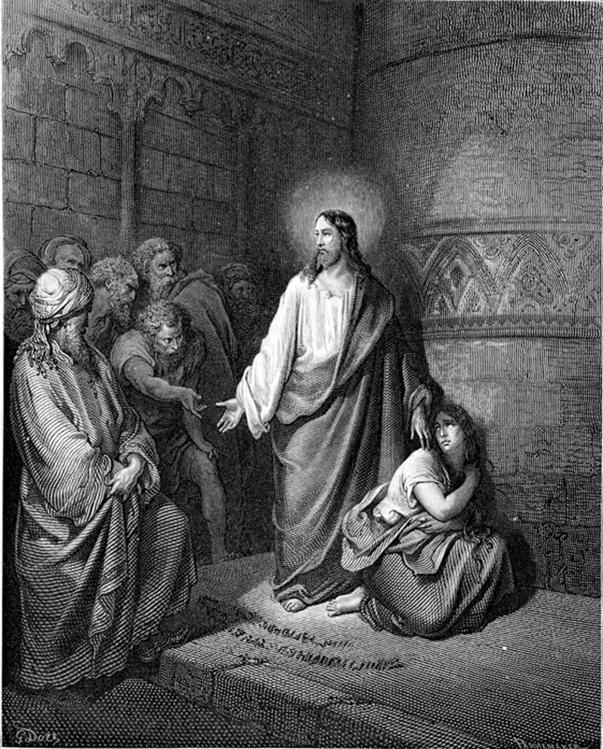
Jesus and the Woman Caught in Adultery

John 7:53-8:11
Then they all went home, but Jesus went to the Mount of Olives. At dawn he appeared again in the temple courts, where all the people gathered around him, and he sat down to teach them. The teachers of the law and the Pharisees brought in a woman caught in adultery. They made her stand before the group and said to Jesus, “Teacher, this woman was caught in the act of adultery. In the Law Moses commanded us to stone such women. Now what do you say?” They were using this question as a trap, in order to have a basis for accusing him.

But Jesus bent down and started to write on the ground with his finger. When they kept on questioning him, he straightened up and said to them, “Let any one of you who is without sin be the first to throw a stone at her.” Again he stooped down and wrote on the ground. At this, those who heard began to go away one at a time, the older ones first, until only Jesus was left, with the woman still standing there. Jesus straightened up and asked her, “Woman, where are they? Has no one condemned you?” “No one, sir,” she said. “Then neither do I condemn you,” Jesus declared. “Go now and leave your life of sin.”

Detriangling Summary
- Detriangling is rarely a comfortable thing to do.
- We need to develop our capacity to live with other people’s discomfort… and our own.
- Being clear about our identity helps us to resist the temptations hidden within triangles.
- When we succumb to triangles we allow the anxiety and expectations of others to define us.
- Detriangling is an invitation to others to grow in their maturity as disciples, to define themselves more clearly as followers of Jesus.
- De-triangling involves staying emotionally connected whilst not being defined by some else’s anxiety.
An opportunity to spend about 20 minutes in a small group focusing on one or other of the following:

Option One Sabbath as Resistance, Walter Brueggemann

Option Two Habits of Anxiety

Option Three 4 Pillar Plan, Dr Rangan Chatterjee

Each group will be hosted by a member of the team, providing space to work with the material, reflect personally, raise challenges and work out your responses.

Who or what defines me?

‘Sabbath as Resistance: Saying No to the Culture of Now’
Brueggemann offers a challenging reframing of Sabbath. When the people of Israel were slaves in Egypt, they were part of an economic system that never rested. Their sole purpose was to make bricks, in response to an ever increasing, relentless demand. The system did not rest and nor did they.

Once God had rescued the people of Israel, God gave them ten commands by which to live. Brueggemann suggests a pattern in the ten commandments:
- • Commandments 1-3 are about who God is and the appropriateness of the people of Israel responding in worship and faithfulness.
- • Commandments 5-10 outline different ways in which God’s people are to live out their relationship with each other - don’t murder, covet, steal, bear false witness, commit adultery or dishonor your parents.
- • Commandment 4 acts as a bridge – keep the Sabbath holy as a day of worship and rest, a holy-day.

One of the things that strikes Brueggemann is that in the anxious Egyptian system (there aren’t enough bricks) the possibility of rest is impossible. By contrast, after God created all thing, God rested. God did not worry about creation. God did not fear what might happen when the creator rested for a day. God is not anxious. God is not driven.

Commandments 5-10 are about neighbourliness, relationships with one another. Brueggemann suggests that commandment 10 overarches these commandments. Commandments 5-9 each have their roots in covetousness – to covet possessions or people, to covet power or significance, to covet security or belonging; cravings for things or people. Brueggemann wonders if covetousness is what compels us not to rest, but to strive.

Brueggemann suggests that our culture and economic system are also characterised, as in Egypt, by anxiety, fear and drivenness; the system relentlessly demands more and more of us. Our culture of consumerism is a culture and economy that doesn’t rest. The market has to be fed. We desire more and more things or experiences, we are endlessly busy. Rest is not an option. The decision to act by stepping away from covetousness and the consumption it drives (of things, relationships, significance, power, etc.) is an act of resistance to our culture and its values and norms.

By its very action of resistance, taking a regular, weekly Sabbath is difficult, unpopular, potentially confrontational and likely to make us and others feel uncomfortable. God did not need to rest and yet God walked in the garden each evening and rested on the Sabbath, setting a pattern for us. He argues it is in this pattern that we hear God give permission for us to let go of the anxious, competitive restlessness of our culture in order to enter into the rest that is God’s promise and gift to us. Taking time to be holy and time to be human.

Brueggemann suggests that we can only follow God’s example of seventh day rest, to take a Sabbath, if we choose to love God and if we choose to develop habits that avoid covetousness. As we rest from the economic system of consumerism and its relentless pressures, we choose not to be anxious or fearful, we give our time and ourselves to worship of God and to human relationships – to neighbourliness. It is in this approach that Sabbath becomes something that transforms us.

Sabbath as Resistance – Small Group Discussion
- Brueggemann suggests that covetousness is what compels us not to rest, but instead to strive. What is your response to this suggestion as you reflect on your self?

- What roots of covetousness do you perceive in your approach to Sabbath and the reasons you give for not taking Sabbath?

- Sabbath is about rest – in a nation of freed slaves, this command was God’s permission not to enter into another work-based slavery. What might be involved in re-creation that is centred on God and takes account of our style and personality, for you, for those in your church?

- Living the Sabbath involves a grace that includes gifts of human intimacy and compassion. We remember to whom we belong, we remember how we live with each other. How might Sabbath enable us to reintroduce meaning and perhaps redirect our energy and focus in the week ahead?

- We anticipate the eschatological party through our weekly celebration of Sabbath. It may include worship, music, food, beauty, community, conversation, joy, wonder, delight and play. It is time to enjoy, not rush past too busy to stop. How might we embrace more of the eschatological party?

A reminder of the definition we are using for anxiety: An automatic emotional response to a threat, real or imagined, experienced as an unfocused sense of discomfort.

In order to identify your personal anxiety habits you will be invited to think back to your family or context of origin and to think about how anxiety was handled there, before thinking about how you handle anxiety as an adult in your current contexts and relationships.

You might find it helpful for this activity to draw a family tree for the family of origin you grew up in, or to write down the names of those in your family of origin.

- How was anxiety handled in those relationships?

- What emotional reactivity do you remember – perhaps outbursts of anger, perhaps withdrawal through silence or absence, perhaps blame and accusation, perhaps rushing to apology and to making things right again.

- Was there a particular person, or particular people, who, as you think about it now, absorbed anxiety or were particularly anxious as ‘normal’?

- Was there a person who was the focus of anxiety of others in the family – perhaps a person with a lot of ill-health, a person who worried a lot about decisions, a person who was deemed to be ‘the black sheep’ or troublesome.

- What anxiety habits do you identify that have followed you into adult life? Might there be particular situations that you get anxious about, how much do you absorb the anxiety of others, how do you feel in the face of anxiety in others and how does their anxiety impact on you?

- How is your leadership defined by or impacted by the anxiety that others pass to you?

- In light of what you have noticed about your family or context of origin and your anxiety habits as an adult what do you want to change? How might you define yourself differently in the face of anxiety? What difference will this make? How might you start to make this change?

Although we aren’t able, in this session today, to explore the 4 pillars of sleep, relax, move and eat, we include them for those who want a resource for investing in the pillars, what we do, as well as investing in the foundations of self and God, which we’ve done in this session.

Dr Chateterjee is a pioneer in the emerging field of progressive medicine, which takes a 360 degree approach to health. This approach was highlighted in his BBC One show, Doctor in the House. He is resident doctor on BBC One’s Breakfast. He wrote The 4 Pillar Plan to make good health accessible to all. Based on current research and his experience as a GP the 4 Pillar Plan provides a simple actionable plan for health. The 4 Pillar Plan takes a full view of health and well-being, making small, achievable changes in four key areas of life, to create and maintain health.

Pillar 1: Relax
Relaxation, or lack of it, is a huge problem these days. Modern life is stressful – with work pressures, constant demands from social media, lack of work/life boundaries and caring for other generations. Relaxation is hard to find. Yet, relaxation has never been more important. The 4 Pillar Plan includes ideas for building relaxation into even the busiest of lives.

Pillar 2: Eat
Healthy eating has become incredibly complicated, with new fad diets every week and new (often contradictory) data about health. This pillar teaches some of the basics of nutrition and gives simple ideas for eating healthily.

Pillar 3: Move
Modern levels of inactivity are impacting on our health. Lack of time is often cited as a reason for not exercising. The plan gives some useful information and simple ideas for getting more movement into your everyday lives, in a fun way!

Pillar 4: Sleep
There are plenty of distractions that keep us from our beds (what is that latest box set you are watching!?) When we finally make it to bed, we often don’t have rejuvenating sleep. The book includes simple strategies to sleep better so that you feel better.

The 4 Pillar Plan isn’t the latest fad for a short-term fix. The 4 Pillar Plan enables you to make small lasting changes that will transform your health and life.

Use the 4 pillars five elements to check where you are already and what you might focus on.

RELAX | EAT | MOVE | SLEEP
Me-time every day.  Every day, for at least fifteen minutes, be selfish, and enjoy some time for you.  Setting aside moments every day can make a difference to your health. There is always something else to do, we need to decide to prioritise time to relax. | De-normalize sugar (and retrain your taste buds).  Retrain your taste buds by removing all sugars from your cupboard and get into the habit of always reading the label on your food to check sugar content. Take the plunge to change your taste buds and address an overreliance on  sugar. | Walk more.  Walk at least 10,000 steps per day.  Walking, like breathing, is one of the core activities that the brain does without the need for conscious control. Get a cheap tracker. | Create an environment of absolute darkness.  Try to keep your bedroom completely dark and free from television or e-devices.  Tips to help us embrace darkness to keep our circadian clock system in time.
Weekly screen-free Sabbath.  Once a week, turn off your screens and live your day off-line.  The goal is to examine, change and reset our relationship with our electronic devices. | Eat five different vegetables every day.  Aim to eat at least five portions of vegetables every day – ideally of five different colours.  The more variety of colours of vegetable on the plate, the more variety of nutrients you are eating. See the vegetable colour chart. | Become stronger.  Do a form of strength training twice a week.  Muscle is a forgotten organ. Strengthening our muscle, has significant health benefits, including: better body composition, improved brain health, better insulin sensitivity, reduced stress and anxiety. | Embrace morning light.  Spend at least twenty minutes outside every morning.  Getting the right kind of light at the right point in the day can have amazing effects throughout our bodies. Have your morning cup of tea or coffee in the garden with a fleece on, or go for a walk.
Keep a gratitude journal.  Every night before you go to sleep, write a list of all the things that have gone well for you that day, and all the things you’re grateful for.  What have you done to make someone happy today? What has someone done to make you happy today? What have you learned? | Eat all your food within a twelve-hour window.  Get into the habit of giving your digest system a twelve-hour fast.  As soon as we give our body a break from eating an extraordinary health-promoting cascade is triggered, which escalates the closer to twelve hours we get. Stop eating after your evening meal and don’t start until the equivalent time with breakfast the next morning. | Do a form of high intensity interval training (HIIT) twice a week.  Find a form of HIIT that works for you and do two ten-minute sessions each week.  Choose a workout that works for you. High impact at the gym or perhaps fast walking in your street (walk fast for five minutes from your home, then five minutes back. Next time aim to get a little further). | Create a bedtime routine.  Start your evening wind-down with a No-Tech-90 Minutes, as part of a set ritual.  The body has its own intrinsic rhythms, we need to try to support them, one way of doing this is to have a pathway that leads us towards sleep.
A daily practice of stillness.  Make time to practice stillness for at least five minutes daily.  We spend most of our time simply overwhelmed by calls for our attention. Practice stillness for at least five minutes a day, perhaps breathing, colouring, sitting in silence, focused listening to music. | Drink eight glasses of water per day.  Increase your water intake for health benefits.  Drinking more water increases energy levels, better bowel function, longer periods of concentration, reduced cravings for sugar and fewer headaches. | Movement snacking.  Make a habit of doing three or four movement snacks five days a week.  Explore the kitchen as your gym, try the office workout, make movement snacking fun by doing it with others. | Manage your commotion.  Minimise any activity that will raise emotional tension before bedtime.  Emotional commotion – a state of alert anxiety, being a bit wound up – in the last part of the day plays a role in the majority of sleep problems. Work out how to wind down from meetings (TV and going online are not the answer!)
Eat one meal per day around the table – without an e-device.  Reclaim your dining table.  Sitting takes us into relaxation mode, we digest food better in relaxation mode. If we can eat round a table with company, this also develops relaxation mode. | Unprocess your diet.  Try to avoid food products that contain more than five ingredients.  Ultra processed food and drink products are energy dense, high in unhealthy fats, refined starches, free sugars and salt, they are poor sources of protein, dietary fibre and micronutrients. Read the ingredients and put it back on the shelf if there are more than five. | Wake up your sleepy glutes.  Do a daily glute exercise to help wake them up, all four exercises twice a week.  One minute exercises to wake up your glutes; switch on your glutes and stand tall. Helps with back problems. | Enjoy your caffeine before noon.  Ensure any caffeine you do choose to consume is taken before lunchtime.  Drink non-caffeine herb tea or sparkling water, reduce your sugar intake and reduce a craving for a caffeine pick-me-up mid-afternoon.
(The 4 Pillar Plan, Dr Rangan Chatterjee – pages 14-15)
- Why not have a go at some of the exercises in the book?

- You could complete the sleep audit (there are some ideas for improving sleep patterns and sleep quality on pages 248-9)

Refreshed? | Alarm? | Time Elapsed? | Total
Do you wake up feeling refreshed? | Do you wake up at the same time (within 30 minutes) every day without an alarm? * | Do you fall asleep within 30 minutes?

Key:
0 = never or rarely
1 = occasionally
2 = almost never

Your total score ______

*We recognise if you have small children living in your home, they probably act as an alarm clock most days!

- How will the rainbow vegetable table be a resource for you?

 | Artichoke  Asparagus  Avocado  Bamboo shoots  Green peppers  Bok choy  Broccoli  Brussels sprouts  Cabbage  Celery | Cucumber  Edamame beans  Garden peas  Rocket  Spinach  Lettuce  Swiss chard  Kale  Okra | Red peppers  Beetroot  Red onions  Red cabbage  Radish  Rhubarb  Tomato  Radicchio | Carrots  Orange peppers  Pumpkin  Butternut squash  Sweet potato  Turmeric root | Sweetcorn  Yellow peppers  Ginger root  Summer squash  Lemons | Olives  Purple carrots  Purple sweet potatoes  Blueberries  Red cabbage  Black rice  Aubergine | Chickpeas  Cauliflower  Mushrooms  Shallots  Seeds  Onions  Garlic  Turnips  Fennel  Nuts  Lentils  Parsnips
Monday
Tuesday
Wednesday
Thursday
Friday
Saturday
Sunday
(Adapted from https://drchatterjee.com/wp-content/uploads/2017/12/Rainbow-Chart.pdf)

Some useful links
- 5 minute kitchen workout (https://drchatterjee.com/5min-kitchen-workout/)
- Wake up your sleepy glutes, movement 1 (https://drchatterjee.com/wake-sleepy-glutes-flex-step/)

