Change vs Transition

Pattern of Change

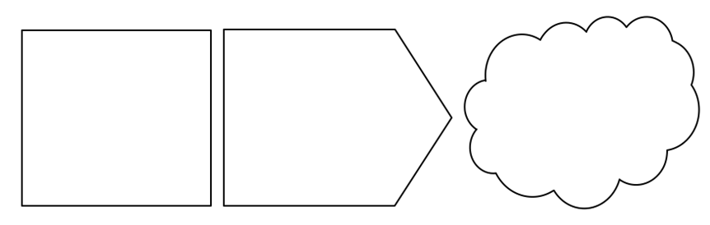

Positive Change

Uninformed optimism

Realistic optimism

informed pessimism

Unrealistic pessimism

Source: The career/entrepreneurial transition curve

Negative Change

Anger

bargaining

acceptance

depression

Denial/rejection

Facing
Backwards
Forwards

Source: On Death and Dying, Elisabeth Küber-Ross, 1969

Four Key Roles

We must do what we
conceive to be the right things and not bother our heads or burden our souls with whether or not we’re going to be successful. Because if we don’t do the right things, we’ll be doing the wrong thing and we’ll just be part of the disease and not part of the cure.
E F Schumacher

Change vs Transition

Pattern of Change

Positive Change

Uninformed optimism

Realistic optimism

informed pessimism

Unrealistic pessimism

Source: The career/entrepreneurial transition curve

Negative Change

Anger

bargaining

acceptance

depression

Denial/rejection

Facing
Backwards
Forwards

Source: On Death and Dying, Elisabeth Küber-Ross, 1969

Four Key Roles

We must do what we conceive to be the right things and not bother our heads or burden our souls with whether or not we’re going to be successful. Because if we don’t do the right things, we’ll be doing the wrong thing and we’ll just be part of the disease and not part of the cure.
E F Schumacher

Principles

’Show up. Speak up. Look up. Team Up. Don't give up. Lift others up.’
Rosabeth Moss Kantar



Approaching the Difficult Conversations

consent

commit

test

+

Perceive

Understand – why and what

Engage – implications

Aware – something

-

Four Main Reasons

Six Main Strategies

