Cycle of Grief
‘I have fought the good fight, I have finished the race, I have kept the faith.’
2 Timothy 4:7

3. Drivenness
We’re driven to achieve more to make ourselves acceptable to others and ourselves.

2. Identity
Our sense of significance is dependent on what we achieve, so we push on.

4. Acceptance
The sense of acceptance is temporary and fragile, so we go round the cycle once again.

1. Achievement (activity)
We achieve to provide
ourselves with an identity.

Cycle of Grace

2. Sustenance
Resources constantly renewed through dependence on God.
(Ephesians 2:7)

3. Identity
Sense of significance.
(Ephesians 2:6)

1. Acceptance
Unconditional grace.
(Ephesians 2:4-5)

4. Fruitfulness

(achievement, service)
In loving, obedient ministry.
(Ephesians 2:10)

What are the privileges and joys of Christian leadership?

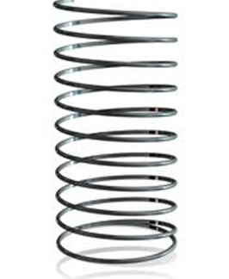

Overstretch

Positive Stretch

How might we look after ourselves so that we don’t tip from positive stretch into overstretch?

‘The hardest work I’ve ever done, and the most stressful, was as a parish priest mainly because it was isolated, insatiably demanding and I was on the whole working without close colleagues – and that wears people down.’
Archbishop Justin Welby, The Guardian, 10 July 2017.

- Strengthen the Spring

- Reduce the weights

- Get Support

Who might be the different load bearing people for each area of stretch?

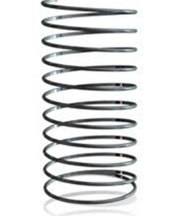

Change

Alignment

Relationships

Expectations

What have we experienced?




Keep Watch

Failure of Nerve —> Failure of Heart
Secure Nerves —> Secure Heart

‘Keep watch over yourselves and all the flock of which the Holy Spirit has made you overseers. Be shepherds of the church of God, which he bought with his own blood’.
Acts 20:28

‘The main thing is to keep the main thing the main thing.’
Stephen Covey

‘So we fix our eyes not on what is seen but on what is unseen since what is seen is temporary but what is unseen is eternal’
2 Corinthians 4:18

‘Fixing our eyes on Jesus, the pioneer and perfecter of faith. For the joy set before him he endured the cross, scorning its shame, and sat down at the right hand of the throne of God.’
Hebrews 12:2

Leading well
- Leadership is about clarity.
- Leadership requires that we solve problems and manage tensions.
- Leadership requires that we communicate things carefully, creatively and continually.
- Leadership requires that we engage with people with difficulties.
- Leadership can at times feel lonely.
- Leadership requires that we expand our capacity for chaos, change and conflict, and increase tolerance for ambiguity.

Change Around us is Slow and Incremental
- More agricultural than industrial.
- Keep at it and be intentional.

You Can do Everything Right and it Can Still Go Wrong
- Bizarre but true.
- Don’t beat yourself up, develop a deep trust in God.

Reality of Disappointment
- We all encounter disappointment with ourselves, those we care for, that are closest to us and even God himself.

Boredom
- Same old same old.
- Keep developing personally and corporately (feedback, feedback, feedback).

Life Mixed
- Inevitable ups and downs.
- Work out how to handle personal stuff when in a public role.

Our stuff likely to be an ongoing issue
- There are generally 2-3 issues that we will grapple with the whole of our lives. Some maybe character, some personality, some circumstantial.
- Bring it to Jesus over and over again.

For reflection

- Which of these connects with you?

- How would you start a conversation with your mentor about this?

‘I write with the conviction that learning to cope with disappointment is a key quality for all leaders to develop. Facing disappointment honestly helps us to build resilience, manage expectations and nurture faith and hope in ways which keep our focus on the author and perfecter of our faith. ‘
Facing Disappointment: The Challenge for Church Leaders, James Newcome (Grove L25)

Guidelines for Quiet Afternoon
- Use the time constructively, be intentional about what you do. The focus of this time is not finishing incomplete integration tasks, reading three books, or preparing the sermon for Sunday! It is on being with God and allowing him to focus on whatever he wants in our lives. So begin the time with an intentional act of giving yourself over to God and being still in his presence.
- To enable quiet within our community, please don’t talk in public spaces and try to move around as quietly as possible.
- Tea/ coffee/ juices will be available at 3.15pm for you to help yourself.
- Prayer is available. Times are displayed on a sheet on the Drawing Room door. Please tick if you want to use one of the slots.
- We will end the silent retreat together in the Garden Room at 5pm for a time of worship and prayer with your sock partner.

Ideas
- Journaling read through your journal of your time on Arrow. What has God been doing? What are the things he still wants to do? What are the trends you can spot?
- Review your Development Plans and Personal Vision Statement What can you give thanks for? Where might God be leading you in the future? What are the changes you want to make to these things for the last part of Arrow (from now until October)?
- Get creative Creative materials are available in the Ball Room. If you don’t normally use such things, think about having a go. Sometimes it can be helpful to express a feeling, approach a problem, or seek guidance using art.
- Reflecting Use the questions below to help you reflect on a variety of Arrow things. Alternatively, we’ve included two pages in this section to help reflection. One is focused around the Arrow strapline, to be led more by Jesus, to lead more like Jesus, to lead more to Jesus. The other is focused on the five competencies at the heart of Arrow.
- 2 Timothy Read through your notes on the Bible teaching this week, or use the summary of Paul’s instructions to Timothy in the yellow pages section.

Suggested Questions for Reflection During the Quiet Time
- What has God been doing in your life during your time on Arrow? What can you give thanks for?
- What are the key principles for life and leadership that you want to make a part of the rest of your life?
- Where does God want you to pay attention at this point?
- What one thing must you absolutely act upon by the end of your time on Arrow (or even the end of today)?
- What are the conversations it would be good to have with my mentor before the end of the programme?
- Using the handouts on developmental roles and the lifeline overview, what questions might it be good to explore over the coming year and with whom would it be best to explore them?

Reflect

- What insights have you gained?

Review

- Identify the areas where you can rejoice over Jesus’ leadership in your life.

- What areas of your life would you like to further submit to Jesus’ leadership?

Revise

- What one thing would you like to do in this area to make the most of your remaining time on Arrow?

Reflect

- What insights have you gained?

Review

- In what ways would you like to lead more like Jesus?

Revise

- What one thing would you like to do in this area to make the most of your remaining time on Arrow?

Reflect

- What insights have you gained?

Review

- What will leading more to Jesus mean for you?

Revise

- What one thing would you like to do in this area to make the most of your remaining time on Arrow?

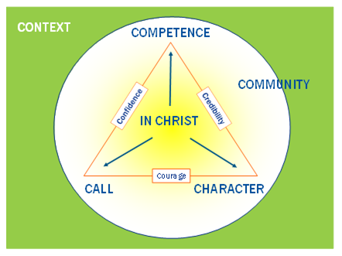

Growing leaders know they are chosen
Where are you in your relationship with God right now?

Growing leaders discern God’s call
What is God calling you to? Where are you excited? Where are you resistant?

Growing leaders develop Christ-like character
What is the character issue God most wants to work on in you? What character issue is likely to scupper you in leadership?

Growing leaders cultivate competence
Where are your strengths in leadership competence? What are the key areas for growth over the next year?

Growing leaders lead in community
Who are you leading with? What would take your leadership with others to the next level?

