# Developing others

## Introduction

## 

## Activity

## 

|  |  |
| --- | --- |
| Top THREE CHALLENGES What are the top three challenges you encounter in developing people? | 1. |
| 2. |
| 3. |
| What makes this a challenge for you? | 1. |
| 2. |
| 3. |

### Aspects of Developing others

1.

2.

3.

4.

5.

6.

7.

8.

# Developing others

## Introduction

**Differences in developing people**

* Line Management.
* Supervision.

**Assumptions**

* People are different.
* Line management is a skill that can be learnt.
* Generosity is a vital attitude.
* There are some distinctives about line managing in a Christian context.
* Good line management yields fruit.
* There are important differences in line managing paid staff and volunteers, but many of the principles are common.

# Developing others

## Introduction

**Activity**

How do you respond to these assumptions?

What other assumptions do you think we can make?

**DEVELOPING OTHERS**

## Good Developers of Others

## 1. Play to Strengths



**What serves the world**

**What you are good at**

**What you love**

Lacks passion

Not sustainable

Self-  
serving

Sweet   
spot

## THE FOUR THINGS THAT MOST HELP PEOPLE TO EXCEL IN A ROLE

## Select the right person.

## Set clear expectations focused on outcomes.

## Motivate appropriately by focusing on strengths.

## Care for whole person.

## ‘You cannot excel in leadership by merely fixing your weaknesses. To excel, you must maximise your strengths.’

## Aubrey Mallphurs

## ‘Work for those who work for you.’

## Steven Sample

**DEVELOPING OTHERS**

## Good Developers of Others

### 2. Attend to Systems and Procedures

#### TWO ASPECTS

## Create effective systems.

## Tailor to individuals.

#### AREAS TO CONSIDER

## Role profiles.

## Regular meetings.

## Procedures.

There are lots of resources online for 1-1 meetings. Take a look at this guide to line management meetings or these templates for nine different types of one to one meetings. You’re unlikely to find one that works for you perfectly, but use them to inform and inspire you in creating your own templates.

**DEVELOPING OTHERS**

## Good Developers of Others

**3. Direct, Support, Adjust**

Managing people is the interplay of direction and support with appropriate adjustment.

|  |  |  |  |
| --- | --- | --- | --- |
| **Inexperienced and apprehensive in specific task.** | **Some experience and appear enthusiastic.** | **Very able but lacks confidence.** | **Very able and confident.** |
| **Specific instruction and direction but not too much detail.** | **Inform or guide. More detail plus engagement helpful.** | **Inspiration, emotional support. Not too much specific instruction.** | **Desired outcome and available if needed.** |

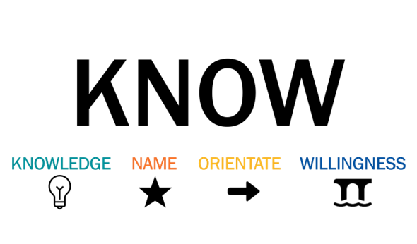

**DEVELOPING OTHERS**

## Good Developers of Others

## 4. Offer Feedback

#### CREATING A CULTURE OF FEEDBACK

## The basis of good feedback is a culture where feedback is the norm.

## Invite it.

## Accept it.

## Apply it.

## Offer it.



## B alanced: focus on building on strengths, working on gaps, managing around limitations, engaging with flaws, growing through weaknesses.

## O wned: by the one offering feedback. Don’t say ‘some people think…’

## O bservable behaviours: as much as possible focus on tangible things and remove emotion and judgementalism.

## S pecific: not ‘it wasn’t very good’ but ‘I am not sure x worked well when you did y because it led to a, b and c.’

## T ailored: to their preferred way of receiving feedback.

‘Without feedback it is remarkably difficult to grow.’

Ed Vaughan

**DEVELOPING OTHERS**

## Good Developers of Others

## 5. Recognise Generational Difference

|  |  |  |  |  |  |
| --- | --- | --- | --- | --- | --- |
|  | **Gen Z (I Gen)**  **2000-** | **Millennials (Gen Y) 1984-2000** | **Busters (Gen X)**  **1964-1983** | **Baby boomers**  **1946-1963** | **Builders**  **1925-1945** |
| **Key question** | Who am I? | What’s my choice? | How does it feel? | Does it work? | Is it true? |
| **Expect leaders to** | Give opportunities, be flexible, inclusive, and generous | Collaborate and involve me from the start | Consult/ understand me | Be competent and professional | Give teaching and direction |
| **Approach to technology** | Hack it | Employ it | Enjoy it | Master it | Hope to outlive it |
| **Preferred methods of communication** | Snapchat, Instagram, YouTube | Twitter, texts , Facebook | Websites and emails | Combination of printed materials and emails | Letters, parish magazines, notice sheets |
| **Approach to communication** | Keep it short | Make it interactive | Keep it real | Just give me the bottom line | Let me know all the details |
| **Approach to learning** | Make it visual, engaging and bite sized. Use story, be vulnerable, and keep it fluid. Works best when it involves blended learning, the flipped classroom, and connects with global concerns. | Make it fun and interactive. Exercises are important, but make sure they are interesting. Works best when it is applicable to my immediate needs, engaging and two-way. Take me on a journey. | Make it relevant and practical. Give me team exercises, in-tray exercises and role play. Works best when it is rigorous and relevant, delivered by an expert. Involve me, make it interactive. | Make me think, give me something new, convince me. Don’t make me take part in role plays. Works best when it is convincing, intelligent, delivered by an authority on the subject. Lecture style is fine. | Make it clear what I need to know. Be precise and expansive in your explanation. |
| **My first commitment is to** | My community (global) | My friends | People as people | My area of work | The organisation |
| **Working together** | I’m looking to connect globally | I’m looking for fun in my team | I need a team to do anything | I see the need to work in a team | I’d prefer to work on my own |
| **Disagreement** | More dialogue, less confrontation | Navigate around it | Get it out in the open and discuss it | Decide according to what is most efficient | Avoid confrontation |
| **Description** | Fluid | Connected | Involved | Busy | Faithful |
| **Mood** | Cautious | Confident | Cautious | Confident | Cautious |

**DEVELOPING OTHERS**

## Common Mistakes

1. Confusing hats: Which hat are we wearing?

2. Too slow to address problems.

3. No development plan.

4. Inflexible Scope.

5. Inflexible Style.

6. Default to our bias.

**DEVELOPING OTHERS**

## Common Mistakes

### Activity

Take one of the challenges identified earlier on and work on ways to address the challenge. Try to identify:

* Why it is a challenge.
* How you could best address the challenge.
* What practical steps you could take.

**DEVELOPING OTHERS**

**For Reflection**

1. **How am I doing on developing others?**

|  |  |  |  |  |  |  |  |  |  |  |
| --- | --- | --- | --- | --- | --- | --- | --- | --- | --- | --- |
| **HOW ARE YOU DOING IN EACH AREA?** | **Not so well** | | | | | **Really well** | | | | |
| **Recruiting** | **1** | **2** | **3** | **4** | **5** | **6** | **7** | **8** | **9** | **10** |
| **Onboarding** | **1** | **2** | **3** | **4** | **5** | **6** | **7** | **8** | **9** | **10** |
| **Developing** | **1** | **2** | **3** | **4** | **5** | **6** | **7** | **8** | **9** | **10** |
| **Managing** | **1** | **2** | **3** | **4** | **5** | **6** | **7** | **8** | **9** | **10** |
| **Motivating** | **1** | **2** | **3** | **4** | **5** | **6** | **7** | **8** | **9** | **10** |
| **Supporting** | **1** | **2** | **3** | **4** | **5** | **6** | **7** | **8** | **9** | **10** |
| **Connecting** | **1** | **2** | **3** | **4** | **5** | **6** | **7** | **8** | **9** | **10** |
| **Praying** | **1** | **2** | **3** | **4** | **5** | **6** | **7** | **8** | **9** | **10** |

1. **How might I better develop others?**
2. **What one next step are you going to take as a result of this session? Please make it simple, doable and attractive. Describe it in the most positive and concrete way possible and write it below (and perhaps on a post-it note to stick somewhere it will remind you to focus on this action over the next 21 days).**

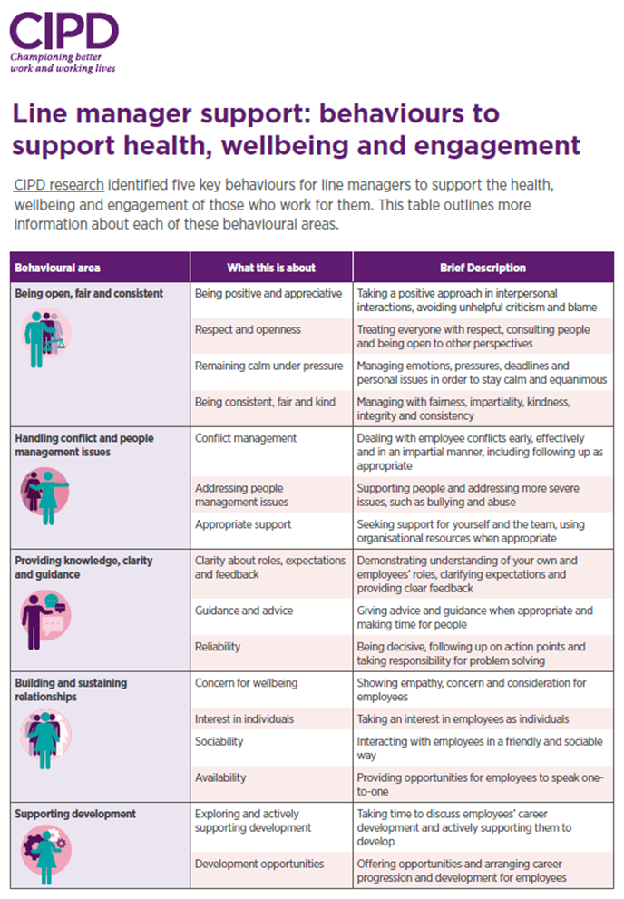

# Developing others

## Delegate Well

Empowerment occurs when an ‘established leader gives authority to an emerging leader within specified boundaries but retains overall responsibility’ (Malphurs).

It is not easy for many leaders because it involves giving up control, slowing down to give time to others, humility, and building connection with other people.

#### Poor ways to delegate

* **Directing** occurs when an established leader retains both responsibility and authority. In some circumstances this is wise and necessary, but generally it inhibits leadership development.
* **Abdicating** occurs when an established leader gives away both authority and responsibility. This means a vital connection between the existing leader and the emerging leader is lost. It usually occurs unintentionally through neglect and is perpetuated by stress and time constraints in the established leader’s life.
* **Disabling** occurs when an established leader gives away responsibility but keeps authority. This cripples the emerging leader because they can’t make decisions and do things their way.

#### When to Delegate

The following material is taken from businessballs.com

Delegation is a win-win when done appropriately, however, that does not mean that you can delegate just anything. To determine when delegation is most appropriate there are five key questions you need to ask yourself:

* Is there someone else who has (or can be given) the necessary information or expertise to complete the task? Essentially is this a task that someone else can do, or is it critical that you do it yourself?
* Does the task provide an opportunity to grow and develop another person's skills?
* Is this a task that will recur, in a similar form, in the future?
* Do you have enough time to delegate the job effectively? Time must be available for adequate training, for questions and answers, for opportunities to check progress, and for rework if that is necessary.
* Is this a task that I should delegate? Tasks critical for long-term success (for example, recruiting the right people for your team) genuinely do need your attention.

If you can answer ‘yes’ to at least some of the above questions, then it could well be worth delegating this job. Other factors that contribute to the delegability of a task include:

1. **The project's timelines/deadlines.**

* How much time is there available to do the job?
* Is there time to redo the job if it's not done properly the first time?
* What are the consequences of not completing the job on time?

1. **Your expectations or goals for the project or task(s), including:**

* How important is it that the results are of the highest possible quality?
* Is an "adequate" result good enough?
* Would a failure be crucial?
* How much would failure impact other things?

#### The steps of successful delegation

1. **Define the task**

Confirm in your own mind that the task is suitable to be delegated. Does it meet the criteria for delegating?



1. **Select the individual or team**

What are your reasons for delegating to this person or team? What are they going to get out of it? What are you going to get out of it?

1. **Assess ability and training needs**

Is the other person or team of people capable of doing the task? Do they understand what needs to be done. If not, you can't delegate.

1. **Explain the reasons**

You must explain why the job or responsibility is being delegated. And why to that person or people? What is its importance and relevance? Where does it fit in the overall scheme of things?

1. **State required results**

What must be achieved? Clarify understanding by getting feedback from the other person. How will the task be measured? Make sure they know how you intend to decide that the job is being successfully done.

1. **Consider resources required**

Discuss and agree what is required to get the job done. Consider people, location, premises, equipment, money, materials, other related activities and services.

1. **Agree deadlines**

When must the job be finished? Or if an ongoing duty, when are the review dates? When are the reports due? And if the task is complex and has parts or stages, what are the priorities? At this point you may need to confirm understanding with the other person of the previous points, getting ideas and interpretation. As well as showing you that the job can be done, this helps to reinforce commitment. Methods of checking and controlling must be agreed with the other person. Failing to agree this in advance will cause this monitoring to seem like interference or lack of trust.

1. **Support and communicate**

Think about who else needs to know what's going on, and inform them. Involve the other person in considering this so they can see beyond the issue at hand. Do not leave the person to inform your own peers of their new responsibility. Warn the person about any awkward matters of politics or protocol. Inform your own boss if the task is important, and of sufficient profile.

1. **Feedback on results**

It is essential to let the person know how they are doing, and whether they have achieved their aims. If not, you must review with them why things did not go to plan, and deal with the problems. You must absorb the consequences of failure, and pass on the credit for success.

#### Levels of delegation

Delegation isn't just a matter of telling someone else what to do. There is a wide range of varying freedom that you can confer on the other person. The more experienced and reliable the other person is, then the more freedom you can give.

The more critical the task then the more cautious you need to be about extending a lot of freedom, especially if your job or reputation depends on getting a good result. Take care to choose the most appropriate style for each situation. For each example the statements are simplified for clarity; in reality you would choose a less abrupt style of language, depending on the person and the relationship. At the very least, a ‘Please’ and ‘Thank-you’ would be included in the requests.

It's important also to ask the other person what level of authority they feel comfortable being given. Why guess? When you ask, you can find out for sure and agree this with the other person.

Some people are confident; others less so. It's your responsibility to agree with them what level is most appropriate, so that the job



is done effectively and with minimal unnecessary involvement from you. Involving the other person in agreeing the level of delegated freedom for any particular responsibility is an essential part of the 'contract' that you make with them.

These levels of delegation are not an exhaustive list. There are many more shades of grey between these black-and-white examples. Take time to discuss and adapt the agreements and 'contracts' that you make with people regarding delegated tasks, responsibility and freedom according to the situation.

Be creative in choosing levels of delegated responsibility, and always check with the other person that they are comfortable with your chosen level. People are generally capable of doing far more than you imagine.

The rate and extent of responsibility and freedom delegated to people is a fundamental driver of organisational growth and effectiveness, the growth and well-being of your people, and of your own development and advancement.

**Examples**

These examples of different delegation levels progressively offer, encourage and enable more delegated freedom. Level 1 is the lowest level of delegated freedom (basically none). Level 10 is the highest level typically (and rarely) found in organisations.

1. **‘Wait to be told.’ or ‘Do exactly what I say.’ or ‘Follow these instructions precisely.’**

This is instruction. There is no delegated freedom at all.

1. **‘Look into this and tell me the situation. I'll decide.’**

This is asking for investigation and analysis but no recommendation. The person delegating retains responsibility for assessing options prior to making the decision.

1. **‘Look into this and tell me the situation. We'll decide together.’**

This is has a subtle important difference to the above. This level of delegation encourages and enables the analysis and decision to be a shared process, which can be very helpful in coaching and development.

1. **‘Tell me the situation and what help you need from me in assessing and handling it. Then we'll decide.’**

This is opens the possibility of greater freedom for analysis and decision-making, subject to both people agreeing this is appropriate. Again, this level is helpful in growing and defining coaching and development relationships.

1. **‘Give me your analysis of the situation (reasons, options, pros and cons) and recommendation. I'll let you know whether you can go ahead.’**

Asks for analysis and recommendation, but you will check the thinking before deciding.

1. **‘Decide and let me know your decision, and wait for my go-ahead before proceeding.’**

The other person is trusted to assess the situation and options and is probably competent enough to decide and implement too, but for reasons of task importance, or competence, or perhaps externally changing factors, the boss prefers to keep control of timing. This level of delegation can be frustrating for people if used too often or for too long, and in any event the reason for keeping people waiting, after they've inevitably invested time and effort, needs to be explained.

1. **‘Decide and let me know your decision, then go ahead unless I say not to.’**

Now the other person begins to control the action. The subtle increase in responsibility saves time. The default is now positive rather than negative. This is a very liberating change in delegated freedom, and incidentally one that can also be used very effectively when seeking responsibility from above or elsewhere in an organisation, especially one which is strangled by indecision and bureaucracy. For example, "Here is my analysis and recommendation; I will proceed unless you tell me otherwise by (date)."



1. **‘Decide and take action - let me know what you did (and what happened).’**

This delegation level, as with each increase up the scale, saves even more time. This level of delegation also enables a degree of follow-up by the manager as to the effectiveness of the delegated responsibility, which is necessary when people are being managed from a greater distance, or more 'hands-off'. The level also allows and invites positive feedback by the manager, which is helpful in coaching and development of course.

1. **‘Decide and take action. You need not check back with me.’**

The most freedom that you can give to another person when you still need to retain responsibility for the activity. A high level of confidence is necessary, and you would normally assess the quality of the activity after the event according to overall results, potentially weeks or months later. Feedback and review remain helpful and important, although the relationship is more likely one of mentoring, rather than coaching per se.

1. **‘Decide where action needs to be taken and manage the situation accordingly. It's your area of responsibility now.’**

The most freedom that you can give to the other person, and not generally used without formal change of a person's job role. It's the delegation of a strategic responsibility. This gives the other person responsibility for defining what changes projects, tasks, analysis and decisions are necessary for the management of a particular area of responsibility, as well as the task or project or change itself, and how the initiative or change is to be implemented and measured, etc. This amounts to delegating part of your job – not just a task or project. You'd use this utmost level of delegation (for example) when developing a successor, or as part of an intentional and agreed plan to devolve some of your job accountability in a formal sense.