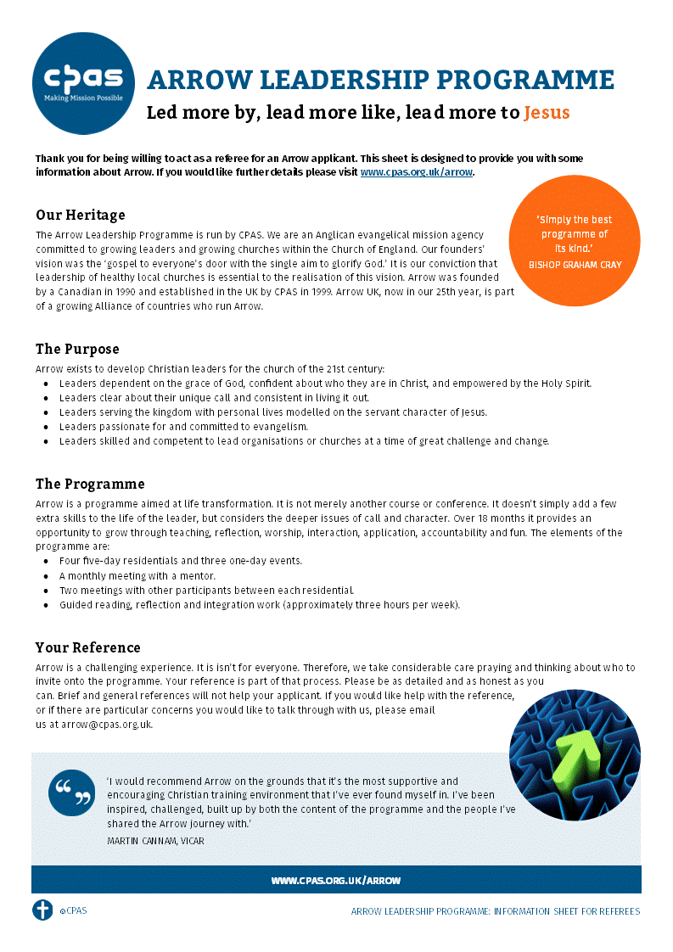


Arrow leadership programme 19

Reference Form

February 2026 – October 2027

Applicant’s Name:
Thank you for being willing to act as a referee. As you complete this reference please bear in mind the suitability of the applicant for the programme based on the information sheet on page 1. If you have any questions, please contact Matt Hustwayte, Arrow Programme Manager at arrow@cpas.org.uk or by calling 0300 123 0780.

We would prefer you to complete this form in Word and return it as an attachment to an email to arrow@cpas.org.uk
Please return by 7 November 2025.

1. Please list the applicant’s gifts/talents?
2. How would you identify the applicant as a leader of leaders?
Not demonstrated☐ | Capable  ☐ |  | Emerging  ☐ | Strong  ☐ | Exceptional  ☒ | Other  ☐
Briefly explain your answer:
3. On a scale where 1=poor and 6=exceptional, how would you currently rate the applicant's skills and abilities as a leader?
1 ☐ | 2 ☐ |  | 3 ☐ | 4 ☐ | 5 ☐ | 6 ☐
Briefly explain your answer:
4. In what ways has the applicant demonstrated a heart for and commitment to evangelism?
5. How open is the applicant to personal growth and development? Please provide a specific example or evidence that demonstrate their willingness to learn, accept feedback, or pursue self-improvement.
6. What do you perceive to be the applicant’s needs for growth and development in the following areas?
a. Their relationship with God.
b. Their character.
c. Their leadership.
d. Their evangelism.
7. If we asked you to describe the applicant in no more than a dozen words, what words would you use?
8. Is there anything else you think we should know? (Please use additional paper if needed).
Your details and relationship to the applicant.
Name:
Address:
Contact number:
Email address:
Occupation:
Applicant’s name:
Relationship to applicant:
Time known:
Are you willing for this reference to be shared with the applicant? |  |  |  |  | Yes ☐ / No ☐
Date:

